Ted Krimmer, 532970

**Stroke Rehabilitation App**

Prototyping and Usability Testing

Assignment 1

Contents

1 Introduction 2

2 Usability Goals and Design Principles 2

3 Testing Methodology 4

3.1 Participant recruitment 4

3.2 Testing 4

3.3 Usability Test Tasks 4

3.4 Success Requirements 4

3.5 Usability Task Matrix table 5

4 Testing Results and Discussion 5

4.1 Testing Summary table 5

4.2 Updates on prototype 5

4.2.1 MainPage 6

4.2.2 Game Set-up 6

4.2.3 GamePage 7

4.2.4 Setting 7

4.3.5 History 8

5 Conclusion 9

References 10

Appendices 11

Appendix A 11

Participant 1 Data 11

Participant 2 Data 12

Participant 3 Data 13

Participant 4 Data 14

Participant 5 Data 15

# 1 Introduction

Stroke rehabilitation can be life-changing; however, it can also be complex and slow. There is no one size fits all with stroke rehabilitation, so I have decided to build this app focusing on hand mobility and improving brain cognition and hand-eye coordination. Stroke rehabilitation often involves doing thousands of repetitions of simple tasks to rebuild the mind-muscle connection(neuroplasticity**)**. This goal will provide the user with an environment to complete a helpful task while making the app easy to use and enjoyable and allowing users to track their progress. The American Stroke Association reports that “10 percent of stroke survivors make an almost complete recovery, while another 25 percent recover with only minor issues.” (Holland, 2021). In the United States almost 800,000 people a year suffer from a stroke according to the Centre for Disease Control and Prevention (CDC) (Centres for Disease Control and Prevention, 2021). I believe with such a large number of people; the app must focus on being easy to navigate and efficient whilst making it worthwhile for their rehabilitation.

# 2 Usability Goals and Design Principles

When designing this app, I considered 6 Usability goals: Learnability on first use, Memorable for repeat users, efficient(user efficiency), failure-resistant, forgiving, and satisfying. I believe that the most important of these goals will be Learnability on first use and enjoyable.

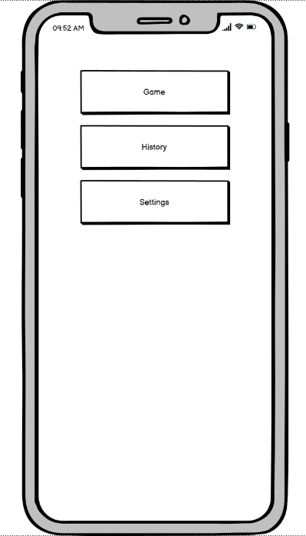I believe making this app have great learnability is the most important goal. Keeping things simple and straightforward will lean into the rest of the goals. With users having such a large market to choose from, I believe if someone struggles to use the app, they will most likely delete it and try something else. In figure 1, you can see my initial design. I have tried to simplify things to help the user understand how to navigate the app. My initial idea of making things simple was challenging for the user, but I will touch on that later.

Figure

I think achieving the first goal should cover the purpose of making the app memorable for repeat users. If a user can figure out the app on first use, then when using the app again should also be easy to remember.

I have tried to implement user efficiency by making it easy to get to sections with as little selection possible. Take Game, for example; I wanted to make it with one press, the user can begin playing the game. In theory, this is ideal; however, after using testing, it made it more difficult for the user to make edits and customise the game.

Failure-resistant is necessary to save the user from improper use. With the low-fidelity prototype, there wasn’t much to implement; however, I plan on making pop-ups to confirm if the user wishes to do things such as deleting history, editing their name, and sharing their history. Making the app satisfying will be further implemented with coding the game and scores.

Donald Norman’s design principles must be considered when designing any application for users. The fundamental principles to consider when building a low-fidelity prototype are visibility, consistency, and affordance.

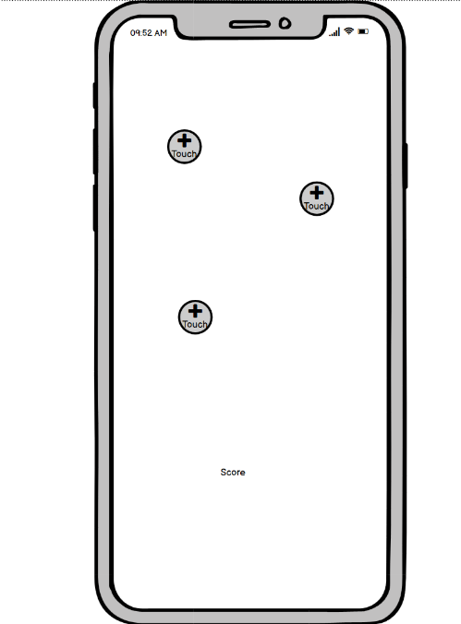Visibility is about showing the user all their options straight away. I think my home page design covers this. I have implemented visibility in figure 1. The user should know that pressing the settings buttons will take them to settings, for example. I have also tried to implement this with the game.

Affordance is the ability of the user to know how to use something as soon as they use it. This links in with my usability goals. In figure 2, I have added buttons that say “touch” on them. This should cover the principle of affordance. The users should know that they need to touch the controls.

Consistency is making the buttons do the same thing every time. When users select settings, it will always take them to the settings page. I have also kept all the buttons in the game the same to adhere to the consistency principle.

Figure

I have tried to make sure the app will look the same, or very similar, on both IOS and android devices. I have done this by trying to use basic buttons and images which can be used on both platforms. Making menu screens as simple buttons rather than using IOS templates. The advantage of this is that using can use both platforms and have the same experience. For example, if a user is using an iPad and a Samsung phone they will be able to change between them with having to relearn how to use the app. The disadvantage of this is that I will have to create my own style to fit both platforms, slowing down production. However, I believe the benefits outweigh the negitvites.

# 3 Testing Methodology

The testing methodology used for testing the low-fidelity prototype was user participation. This is done by gathering users and asking them to complete the app tasks and record their results. The observation was done with Direct observation by sitting with the user as they went about completing the tasks then asking the users questions based on the experience. Sitting with the user while they used the app, I made notes allowing testing to be done with the think-aloud method of testing to capture the user’s thoughts as they went.

## 3.1 Participant recruitment

My initial testing was done in class. I was able to get three other students to participate in testing. I was then able to ask friends who work as occupational therapists to participate in testing. Having ordinary users and health professionals testing the app will provide good feedback from both sides of potential users.

## 3.2 Testing

I conducted my initial tests with other students in class by using my laptop with the app set-up and asking them to complete tasks. Then the rest of my testing was done at home, with friends coming over with the same setup on my laptop. I asked each participant to complete six tasks unaided. These are listed below as my usability test tasks. I then rated the success of the testing based on these success requirements see below.

## 3.3 Usability Test Tasks

1. “Perform simple repetition hand **exercise.”**
2. “Set your goals for the exercise”
3. “Complete the exercise in a **free-play** mode.”
4. “View your exercise history.”
5. “Delete an attempt you don’t want to keep.”
6. “Edit the name that appears in the app.”

## 3.4 Success Requirements

1. Patients should be able to complete a simple repetition hand **exercise**
2. Users should be able to set a **goal** (number of repetitions or time limit) for the exercise.
3. Users should be able to choose to complete the exercise in a **free-play** mode (no repetition limit or time limit).
4. Users should be able to see a **history** of completed exercise attempts.
5. Users should be able to **delete** unwanted completed exercise attempts.
6. Users should be able to **edit** their name as it appears in the app.

If the testing is to be considered successful, the user must be able to complete tasks unaided. I gave each user six tasks to complete then observed and recorded the results. Below is a summary of the task and which success requirements they should cover

## 3.5 Usability Task Matrix table

|  |  |  |  |  |  |  |
| --- | --- | --- | --- | --- | --- | --- |
| **Usability Task Matrix** | R1 | R2 | R3 | R4 | R5 | R6 |
| T1 | x |  |  |  |  |  |
| T2 |  | x |  |  |  |  |
| T3 |  |  | x |  |  |  |
| T4 |  |  |  | x |  |  |
| T5 |  |  |  |  | x |  |
| T6 |  |  |  |  |  | x |

# 4 Testing Results and Discussion

The testing was done, and it is evident that there was still a lot that needed to be changed and added. I knew that many of the tests would not be possible after the first attempt seeing as they were not added to the prototype yet. However, I continued the testing to see if more elements were missing. As seen in the table below, tasks two, three and six were not achieved by anyone because it was impossible.

## 4.1 Testing Summary table

|  |  |  |  |
| --- | --- | --- | --- |
| **Task Summary** | Success rate | Time Taken | Avg number of errors |
| T1 | 100% | 5 seconds | 0 |
| T2 | 0% | NA | NA |
| T3 | 0% | NA | NA |
| T4 | 100% | 2 seconds | 0 |
| T5 | 100% | 3 seconds | 0 |
| T6 | 0% | NA | NA |

## 4.2 Updates on prototype

Based on the testing results, I made some changes to the app. Most were functional fixes with adding features and making movement around the app more accessible. I also added a few decorative elements which aren’t related to the testing I feel added to the app.

### 4.2.1 MainPage

Below in figure 3 is a picture of the app before and after testing. I haven’t added any more functions to the main page, but I added a title and an icon. This will be important for my usability goal of Memorable for repeat users.

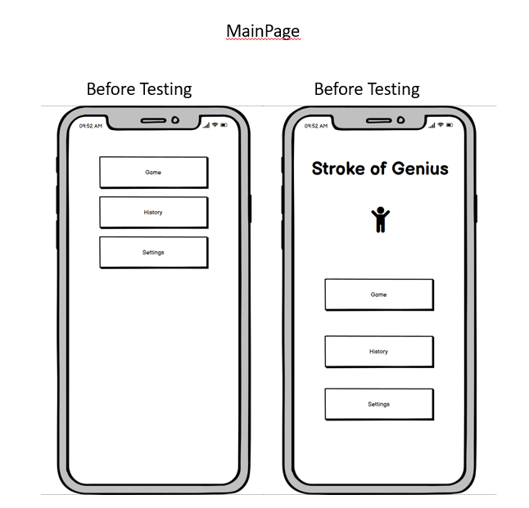

Figure 3

### 4.2.2 Game Set-up

Below in figure 4 are the changes I made to the game set-up page. I needed to add the user's ability to set their goals for the exercise or **select a free play mode with no goals**. I also added a button to return users to the main page in the top left. Not having this was a big oversite and made it very frustrating for the users testing the app.

Figure 4

### 4.2.3 GamePage

For the game, I just added a view for the goals that were set with “time left” and “repetitions left”. While it doesn’t improve the function of the game, it does inline better with Donald Norman’s design principles. Seen in figure 5.

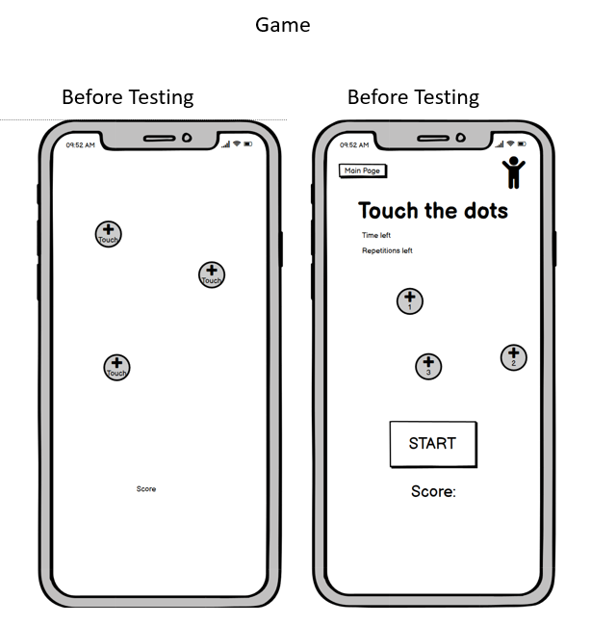

Figure 5

### 4.2.4 Setting

The settings page was just a template in my testing phase; however, I realised from testing that I needed to add the ability to edit the user’s name. I have also added an option to share your history and upload our images for **exercises** as shown in figure 6 below.

Figure 6

### 4.3.5 History

For the History page, I have added more data to be shown to comply with the requirements for the app. This is seen in figure 7.

Figure 7

# 5 Conclusion

I believe making this app have great learnability is the most important goal. Keeping things simple and straightforward will lean into the rest of the goals. Through the prototype and testing phase, I made some observations and changed the app accordingly. Using the think-aloud strategy, I was able to make observations on not only the results of errors, but I was also able to pick up valuable ideas on improving. These app improvements were both functional and visual. The usability testing results have shown there were a lot of fixes needed for the app. Seeing how much the app was changed by just having five people testing the app shows the value of having users attempt to complete tasks. Futures tests will need to be conducted on the updated prototype to see any improvement or if more issues are found. The app menus and functionality are now in a much better stage than before testing.

# References

Centres for Disease Control and Prevention, 2021. *CDC.* [Online]   
Available at: https://www.cdc.gov/stroke/facts.htm  
[Accessed 18 03 2022].

Holland, K., 2021. *Healthline.* [Online]   
Available at: https://www.healthline.com/health/stroke  
[Accessed 15 03 2022].

# Appendices

## Appendix A

Data

### Participant 1 Data

|  |  |
| --- | --- |
| Participant 1 |  |
| Task 1 | Perform simple repetition hand **exercise** |
| Success | Yes |
| Time taken | 5 seconds |
| Observation | Easily completed task |
| Error | 0 |
| User comments | Worked wonderfully |
|  |  |
| Task 2 | Set your goals for the exercise |
| Success | No |
| Time taken | 5 seconds |
| Observation | Couldn’t complete the task |
| Error | 0 |
| User comments | There was no way to set goals. |
|  |  |
| Task 3 | Complete the exercise in a **free-play** mode |
| Success | no |
| Time taken | 5 seconds |
| Observation | Couldn’t complete the task |
| Error | 0 |
| User comments | I couldn’t find a free-play mode. |
|  |  |
| Task 4 | View your exercise history |
| Success | Yes |
| Time taken | 2 seconds |
| Observation | Easily completed task |
| Error | 0 |
| User comments | Easy to find |
|  |  |
| Task 5 | Delete an attempt that you don’t want to keep |
| Success | no |
| Time taken | 5 seconds |
| Observation | Couldn’t find a way to delete the history. |
| Error | 0 |
| User comments | If you can, it is well hidden. |
|  |  |
| Task 6 | Edit the name that appears in the app |
| Success | No |
| Time taken | 4 seconds |
| Observation | No way to complete the task |
| Error | 0 |
| User comments | Couldn’t complete |

### Participant 2 Data

|  |  |
| --- | --- |
| Participant 2 |  |
| Task 1 | Perform simple repetition hand **exercise** |
| Success | Yes |
| Time taken | 4 seconds |
| Observation | Easily completed task |
| Error | 0 |
| User comments | Easy to find |
|  |  |
| Task 2 | Set your goals for the exercise |
| Success | No |
| Time taken | 6 seconds |
| Observation | Couldn’t complete the task |
| Error | 0 |
| User comments | It needs to be more accessible. |
|  |  |
| Task 3 | Complete the exercise in a **free-play** mode |
| Success | no |
| Time taken | 8 seconds |
| Observation | Couldn’t complete the task |
| Error | 0 |
| User comments | I couldn’t find a free-play mode. |
|  |  |
| Task 4 | View your exercise history |
| Success | Yes |
| Time taken | 3 seconds |
| Observation | Easily completed task |
| Error | 0 |
| User comments | Nice feature. Could add more data to view |
|  |  |
| Task 5 | Delete an attempt that you don’t want to keep |
| Success | no |
| Time taken | 7 seconds |
| Observation | Couldn’t find a way to delete the history. |
| Error | 0 |
| User comments | Maybe add it to the bottom of the history page. |
|  |  |
| Task 6 | Edit the name that appears in the app |
| Success | No |
| Time taken | 4 seconds |
| Observation | No way to complete the task |
| Error | 0 |
| User comments | Couldn’t complete |

### Participant 3 Data

|  |  |
| --- | --- |
| Participant 3 |  |
| Task 1 | Perform simple repetition hand **exercise** |
| Success | Yes |
| Time taken | 1 second |
| Observation | Easily completed task |
| Error | 0 |
| User comments | Very easy to start the game |
|  |  |
| Task 2 | Set your goals for the exercise |
| Success | No |
| Time taken | 5 seconds |
| Observation | Couldn’t complete the task |
| Error | 0 |
| User comments | Not sure where this is |
|  |  |
| Task 3 | Complete the exercise in a **free-play** mode |
| Success | no |
| Time taken | 5 seconds |
| Observation | Couldn’t complete the task. |
| Error | 0 |
| User comments | I couldn’t find a free-play mode. |
|  |  |
| Task 4 | View your exercise history |
| Success | Yes |
| Time taken | 2 seconds |
| Observation | Easily completed task |
| Error | 0 |
| User comments | This is a nice feature. |
|  |  |
| Task 5 | Delete an attempt that you don’t want to keep |
| Success | no |
| Time taken | 5 seconds |
| Observation | Couldn’t find a way to delete the history. |
| Error | 0 |
| User comments | Not sure how to do this |
|  |  |
| Task 6 | Edit the name that appears in the app |
| Success | No |
| Time taken | 4 seconds |
| Observation | No way to complete the task |
| Error | 0 |
| User comments | This is dumb. I don’t know how to do it. |

### Participant 4 Data

|  |  |
| --- | --- |
| Participant 4 |  |
| Task 1 | Perform simple repetition hand **exercise** |
| Success | Yes |
| Time taken | 3 seconds |
| Observation | Easily completed task |
| Error | 0 |
| User comments |  |
|  |  |
| Task 2 | Set your goals for the exercise |
| Success | No |
| Time taken | 4 seconds |
| Observation | Couldn’t complete the task. |
| Error | 0 |
| User comments |  |
|  |  |
| Task 3 | Complete the exercise in a **free-play** mode |
| Success | no |
| Time taken | 6 seconds |
| Observation | Couldn’t complete the task. |
| Error | 0 |
| User comments |  |
|  |  |
| Task 4 | View your exercise history |
| Success | Yes |
| Time taken | 4 seconds |
| Observation | Easily completed task |
| Error | 0 |
| User comments |  |
|  |  |
| Task 5 | Delete an attempt that you don’t want to keep |
| Success | no |
| Time taken | 8 seconds |
| Observation | Couldn’t find a way to delete the history. |
| Error | 0 |
| User comments |  |
|  |  |
| Task 6 | Edit the name that appears in the app |
| Success | No |
| Time taken | 4 seconds |
| Observation | No way to complete the task |
| Error | 0 |
| User comments |  |

### Participant 5 Data

|  |  |
| --- | --- |
| Participant 5 |  |
| Task 1 | Perform simple repetition hand **exercise** |
| Success | Yes |
| Time taken | 6 seconds |
| Observation | Easily completed task |
| Error | 0 |
| User comments | Straight forward |
|  |  |
| Task 2 | Set your goals for the exercise |
| Success | No |
| Time taken | 6 seconds |
| Observation | Couldn’t complete the task |
| Error | 0 |
| User comments | Not sure how to do this |
|  |  |
| Task 3 | Complete the exercise in a **free-play** mode |
| Success | no |
| Time taken | 3 seconds |
| Observation | Couldn’t complete the task |
| Error | 0 |
| User comments | I couldn’t find a free-play mode. |
|  |  |
| Task 4 | View your exercise history |
| Success | Yes |
| Time taken | 3 seconds |
| Observation | Easily completed task |
| Error | 0 |
| User comments | Straight forward |
|  |  |
| Task 5 | Delete an attempt that you don’t want to keep |
| Success | no |
| Time taken | 6 seconds |
| Observation | I couldn’t find a way to delete the history. |
| Error | 0 |
| User comments | I couldn’t find it |
|  |  |
| Task 6 | Edit the name that appears in the app |
| Success | No |
| Time taken | 4 seconds |
| Observation | No way to complete the task |
| Error | 0 |
| User comments | Couldn’t complete |